Context

Till Grallert

## Title:

### Till Grallert, Orient-Institut Beirut

### Date, Context

Slides: [tillgrallert.github.io/Slides/name](https://tillgrallert.github.io/Slides/name)

Twitter: @[tillgrallert](https://twitter.com/tillgrallert)

Email: [grallert@orient-institut.org](mailto:grallert@orient-institut.org)

## Outline of today’s talk

1. Introduction and story telling
2. Research question(s) and methodology
3. Empirical results and argument
4. Food riots as a repertoire of contention
5. Conclusion

## 1.1 Food riot in Beirut, 11 August 1908

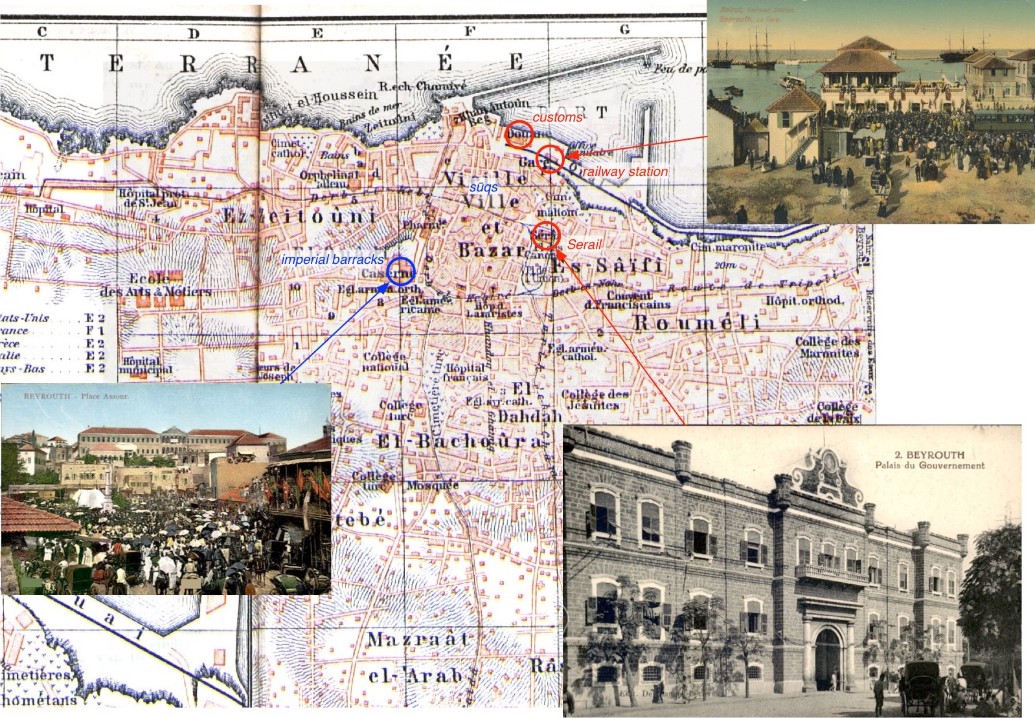

Map: Wagner & Debes. “Beyrout: Vieille Ville et Bazar.” *Palestine and Syria with Routes Through Mesopotamia and Babylonia and the Island of Cyrus: Handbook for Travellers.* 1:25000. 5. ed. Leipzig: Karl Baedeker, 1912.

## 1.1 Food riot in Hama, 11 August 1910

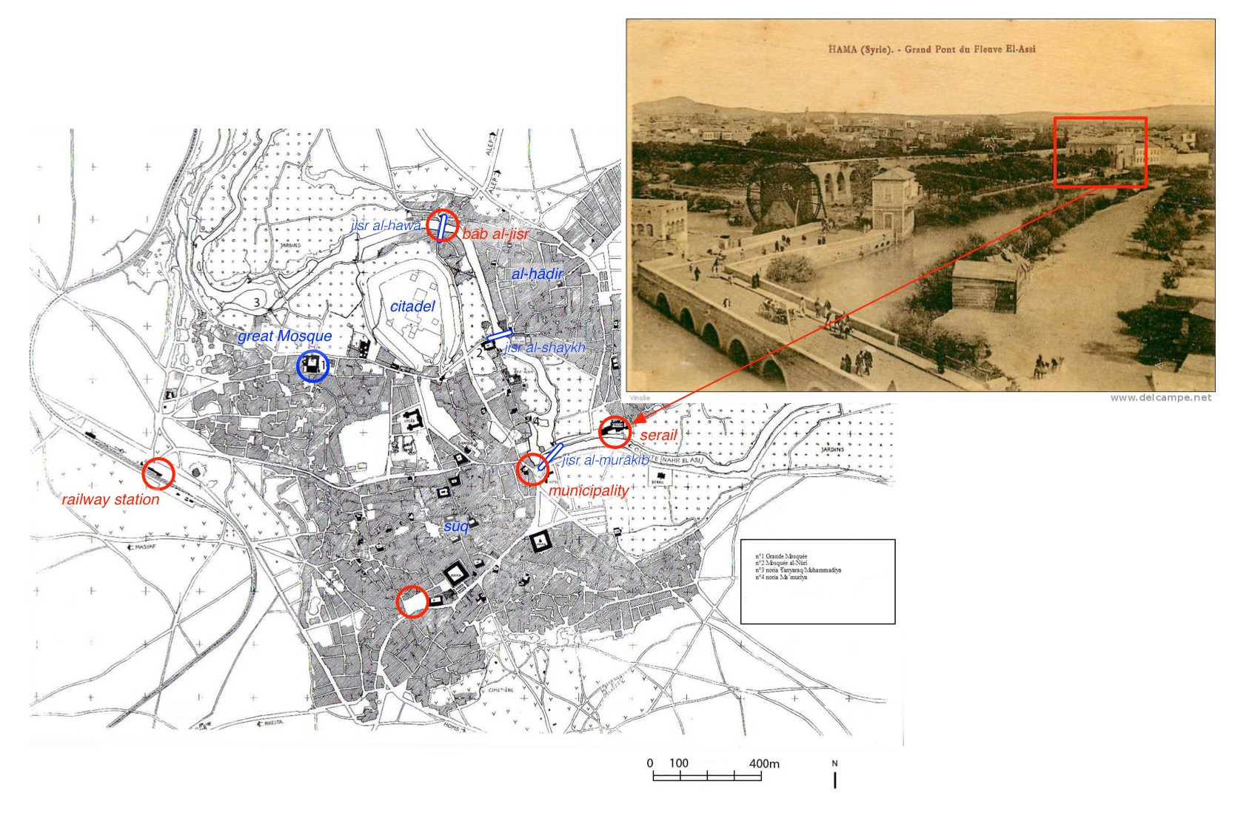

Map: Pentz, Peter. *The Medieval Citadel and Its Architecture.* Hama: fouilles et recherches de la fondation Carlsberg 1931-1938 IV/1. København: Nationalmuseet, 1998

## 1.1 Food riot in Hama, 11 August 1910

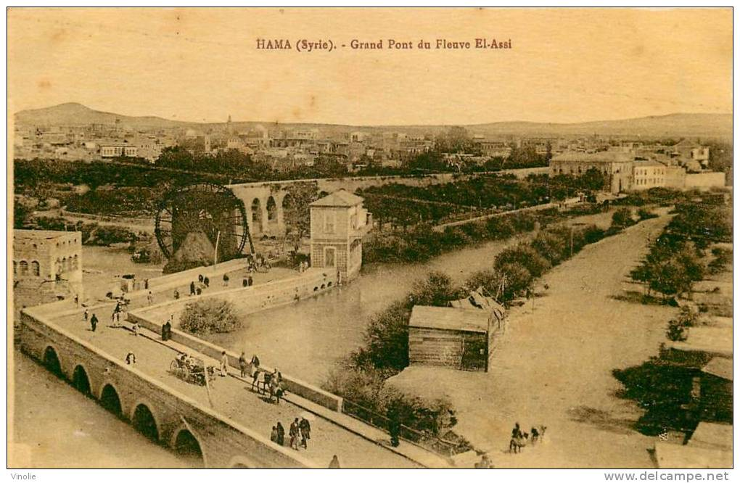

Wattar Frères No. 58. Unknown photographer. Hama (Syrie) - Grand Pont du Fleuve El-Assi. Alep: Wattar Frères (N.D.).

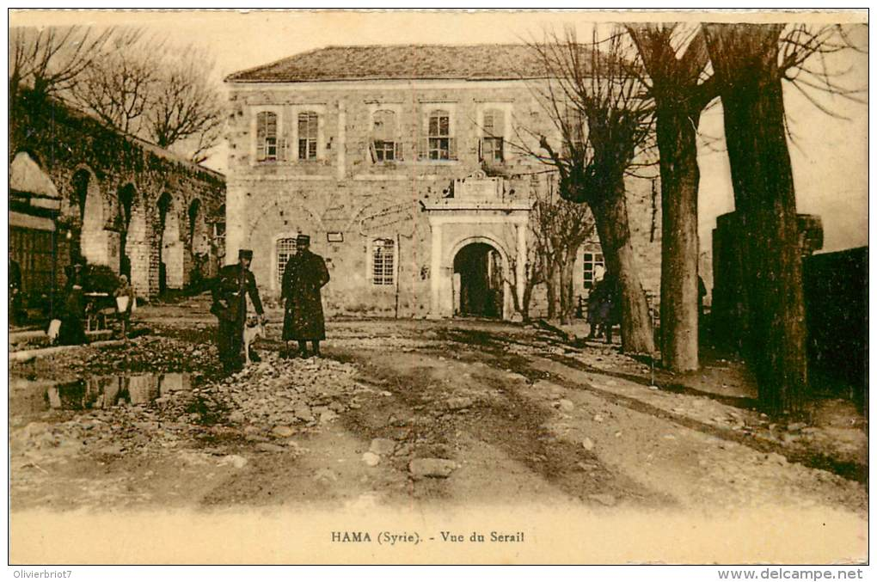

Wattar Frères No. 62. Unknown photographer. HAMA (Syrie) — Vue du Serail. Alep: Wattar Frères, 1922.

## 1.1 Food riot in Hama, 11 August 1910

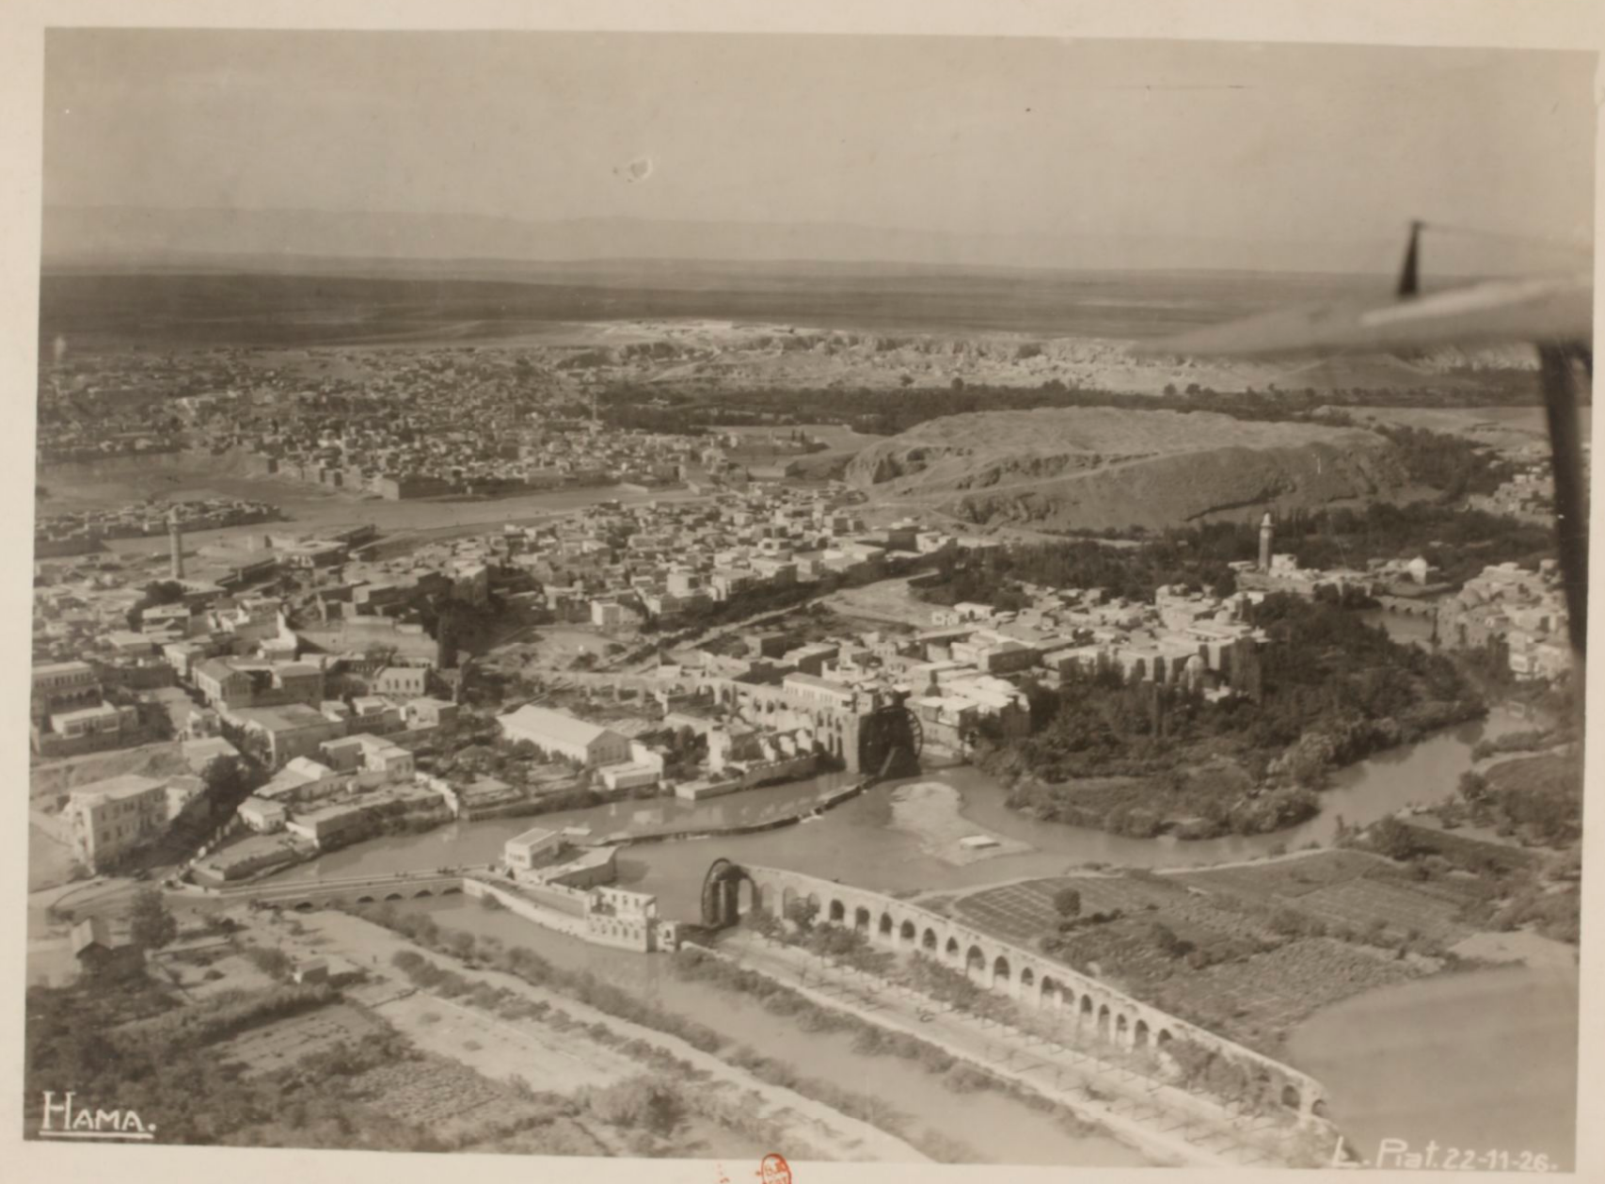

*[Vues Aériennes de Syrie et du Liban] / 39e Régiment D’aviation [Armée du Levant].* Photography by G. David, Loquinaire and L. Piat. N.Pl.: Établissement cinématographique et photographique des armées (France). 1927, G130863 <http://gallica.bnf.fr/ark:/12148/btv1b8443060c/f14.item>

## 1.2 First observations

* there is no or at least no immediate looting
* crowds address the political authorities, predominantly peacefully
* crowds gather at central places, i.e. on the streets and in front of the seat of the political authorities
* women are a (substantial) part of the protests

# 2. Question and methodology

## 2.1 Research question

1. What is the **function** of food riots—immediate remedy for hunger, lower and stable bread prices in the long term, political change?
2. What are the **implications** of food riots for the study of Middle Eastern societies?

## 2.2 Methodology

* Capture and analysis of economic data on food prices
* Detailed case studies on individual food riots
* Systematic analysis of all food riots as part of a “repertoire of contention”

## 2.3 Sources

* Local newspapers and periodicals
* Consular reports
* Ottoman archival documents
* First person accounts

## 2.3 Sources: newspapers

* state of collections
* mode of production

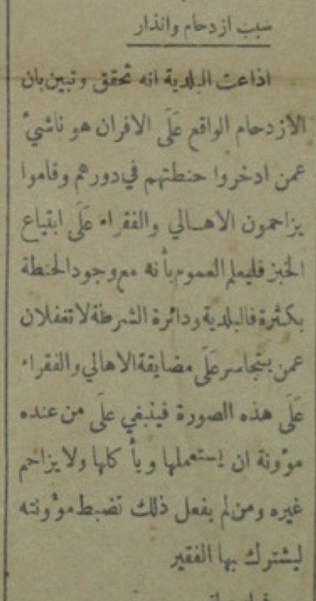

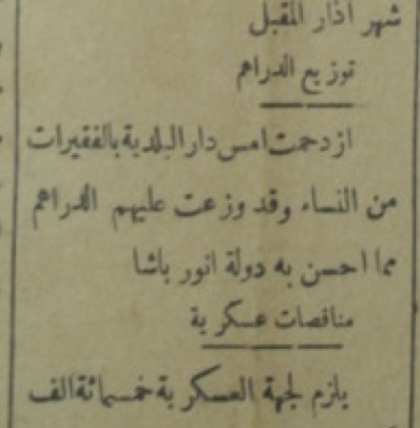

## 2.4 Sample

* 1. 600 price observations for cereals and bread
  2. 400 qualitative statements on food prices
* 19 food riots between 1875 and 1920 in Aleppo, Beirut, Damascus, Hama, Homs, Jaffa, and Jerusalem

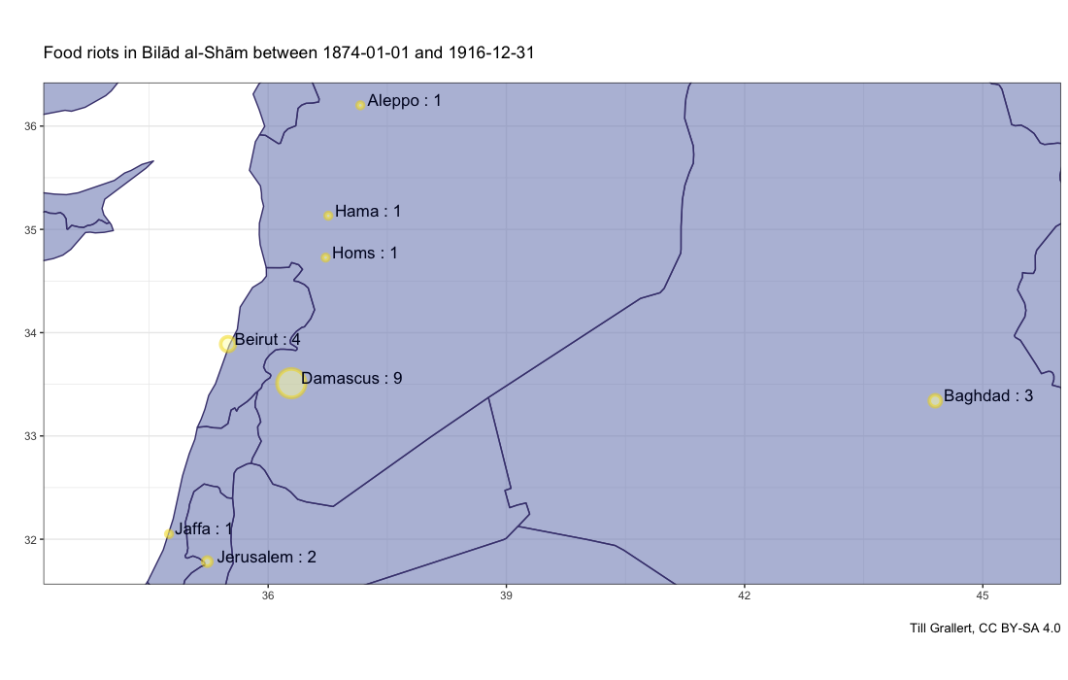

# 3. First results and argument

## 3.1 Empirical results

1. There is no direct causal relation between food riots and food prices
2. Food riots are a relatively stable “repertoire of contention” and take the form of a demonstration

## Food prices and food riots

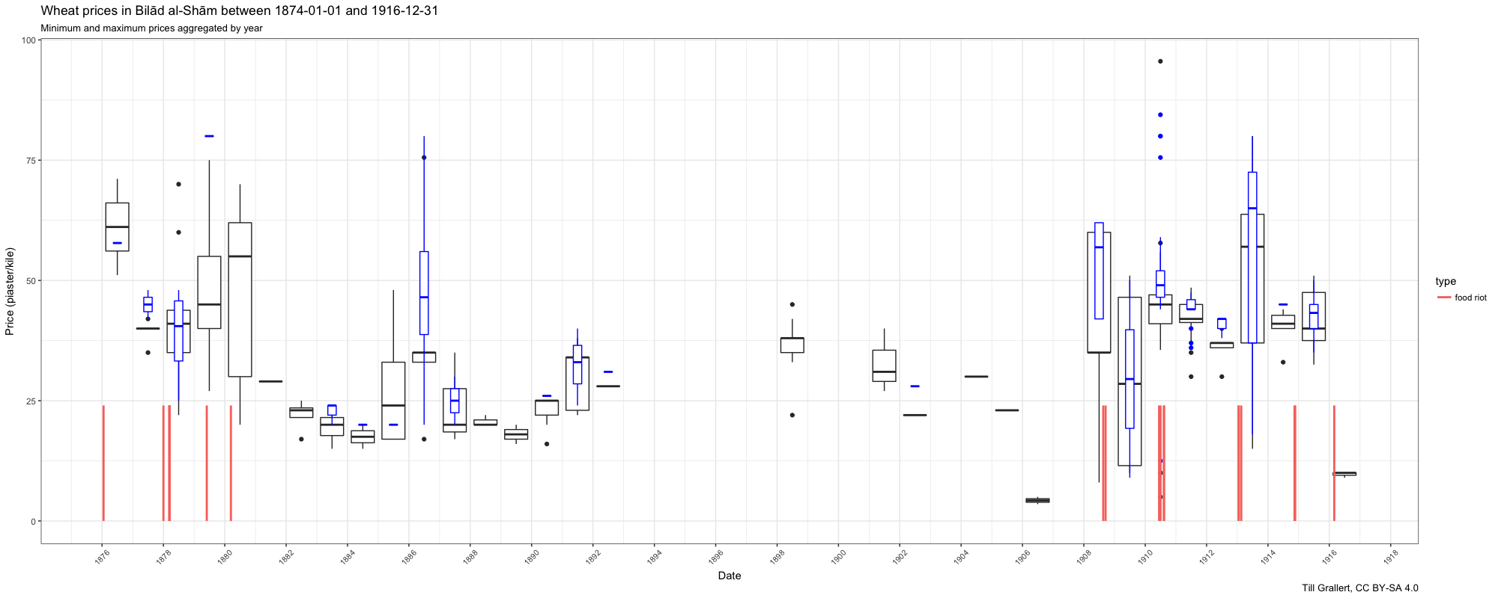

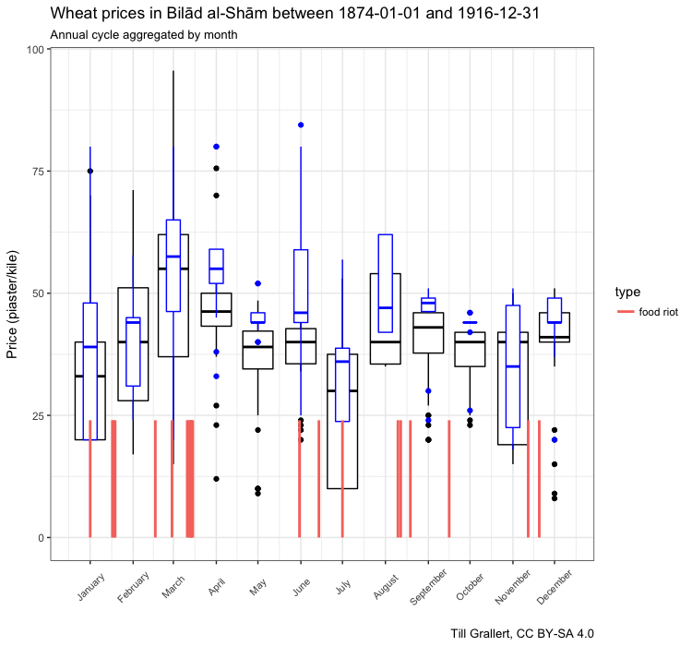

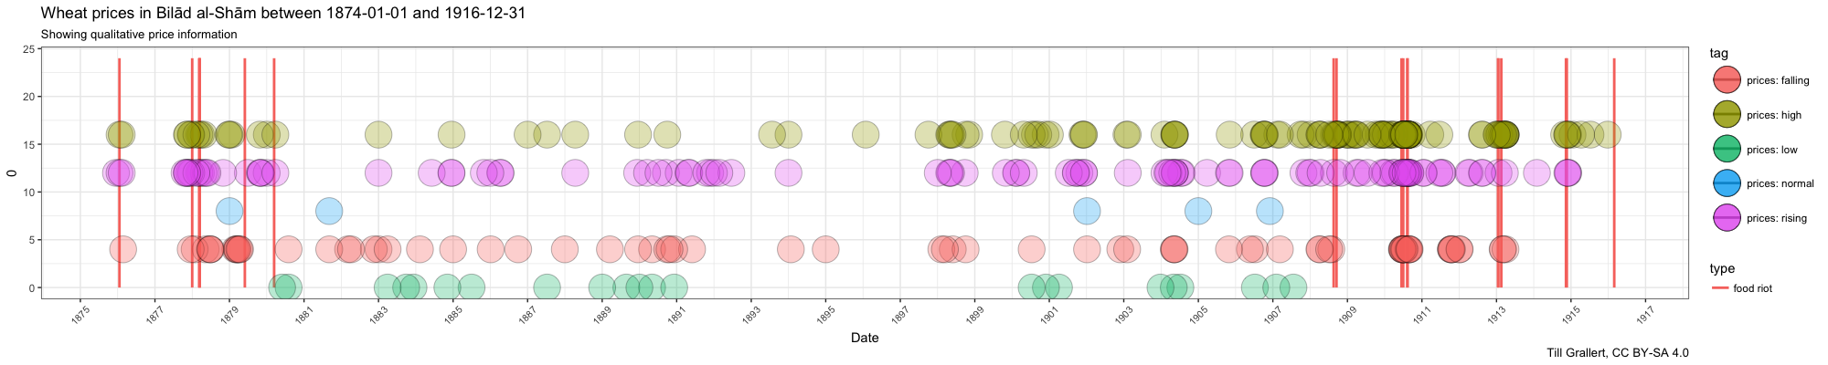

## 3.2 argument

1. There is no direct causal relation between food prices and food riots
2. Food riots are a **tactic** choice on behalf of the protestors and an **inherently political** act
3. Food riots are part of a relatively stable “repertoire of contention” (C. Tilly) and a symbolic repertoire
4. The main target of this conscious political **tactic** are the ruling authorities; protestors call for **equitable distribution** and **fair access** to **available bread**.
5. Food riots are thus part of the negotiations over political legitimacy **within** the existing political order as based in **just rule**, **safety of life**, etc. The demands are conservative and principally recognised as legitimate

# 4. Repertoire of contention

## 4.1 Prologue (weeks)

1. Period of **artificially** high prices
2. Advantageous moment

## 4.2 the food “riot” (few hours, a day)

1. A crowd of poor people—men, women and children—gathers
2. The crowd marches onto the seat of the local government and peacefully raises its demand for affordable bread and grain
3. The crowd is violently dispersed / a combination of promises and threats leads the crowd to dissolve. Original failure of the authorities leads to further escalation.
4. (optional) The crowds turn on merchants and loot warehouses, stores, and railway stations
5. Successful intervention of the highest representative of the central authorities with the help of imperial troops

## 4.3 Aftermath (weeks and months)

1. Intervention from the highest representative of the central authorities
2. No reports on falling grain prices.

# 5. Conclusion

## 5.1 Summary

* Contrary to common arguments and presumptions, we find a long “tradition” of popular contentions in general and food “riots” in particular as well as female agency in genuinely political struggles in public places / space.
* There is no direct causal relation between food riots and food prices.
* Food riots are a relatively stable “repertoire of contention”.
* Food riots are a **tactic** choice on behalf of the protestors and an inherently political act. They are part of the negotiations over political legitimacy **within** the existing political order as based in **just rule**, **safety of life**

## 5.2 Conclusion: open questions

* What about **dangerous classes** and the **lumpenproletariat**?
* What are the **implications** of food riots for the study of Middle Eastern societies?